Week 03
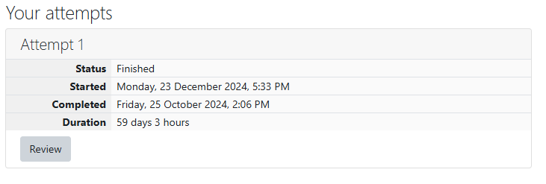
Write a program to read two integer values and print true if both the numbers end with
the same digit, otherwise print false.
Example: If 698 and 768 are given, program should print true as they both end with 8
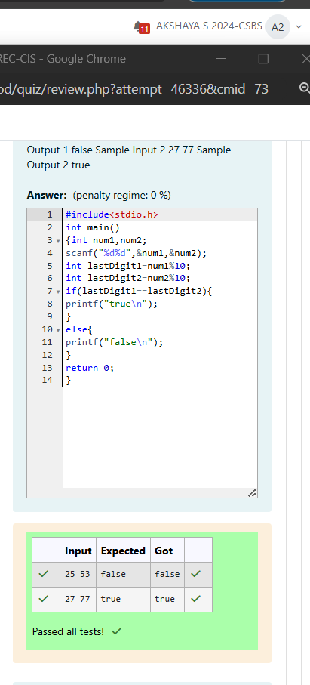
Problem Statement:
In this challenge, we're getting started with conditional statements.
Task
Given an integer, n, perform the following conditional actions:
• If n is odd, print Weird
• If n is even and in the inclusive range of 2 to 5, print Not Weird
• If n is even and in the inclusive range of 6 to 20, print Weird
• If n is even and greater than 20, print Not Weird
Complete the stub code provided in your editor to print whether or not n is weird.
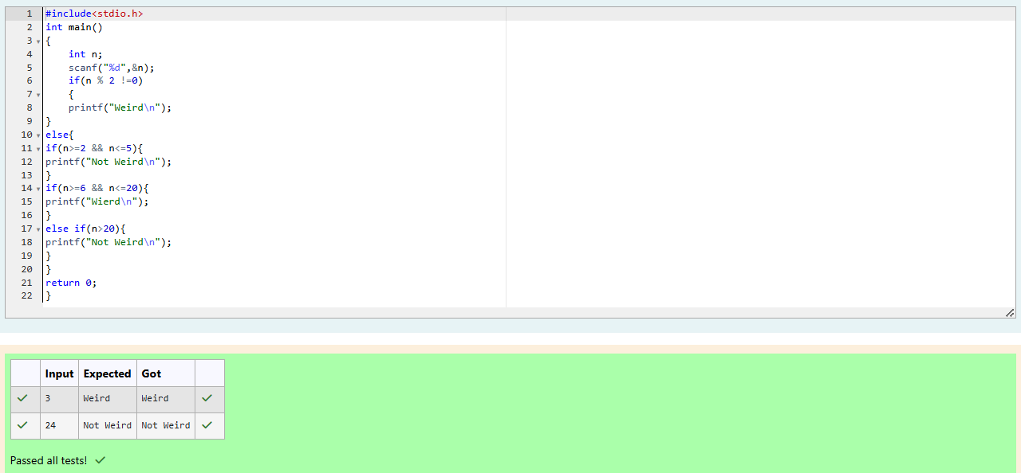
Problem Statement:
Three numbers form a Pythagorean triple if the sum of squares of two numbers is equal to
the square of the third.
For example, 3, 5 and 4 form a Pythagorean triple, since 3*3 + 4*4 = 25 = 5*5
You are given three integers, a, b, and c. They need not be given in increasing order. If
they form a Pythagorean triple, then print "yes", otherwise, print "no". Please note that the
output message is in small letters.
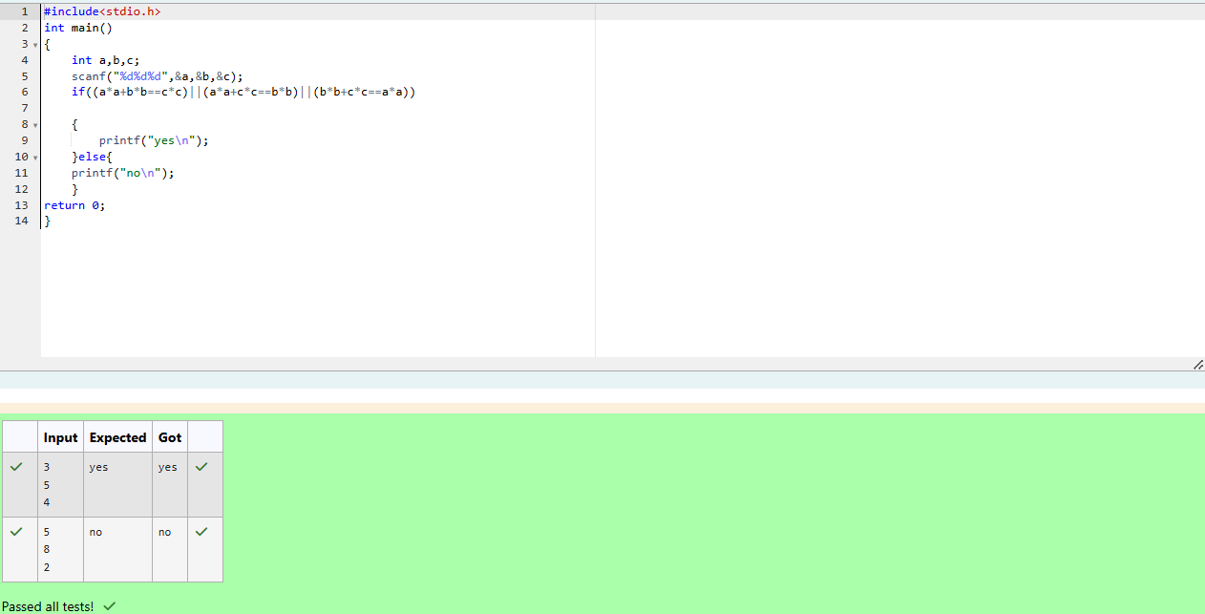
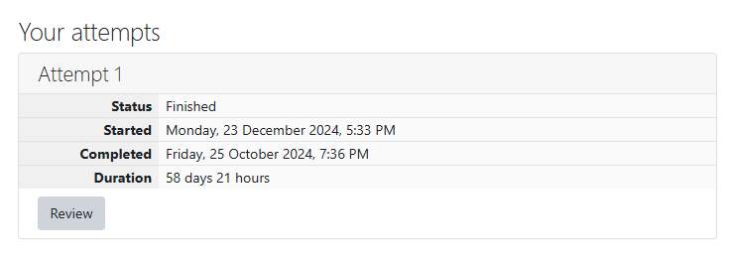
Problem Statement:
Write a program that determines the name of a shape from its number of sides. Read the
number of sides from the user and then report the appropriate name as part of a
meaningful message. Your program should support shapes with anywhere from 3 up to
(and including) 10 sides. If a number of sides outside of this range is entered then your
program should display an appropriate error message.
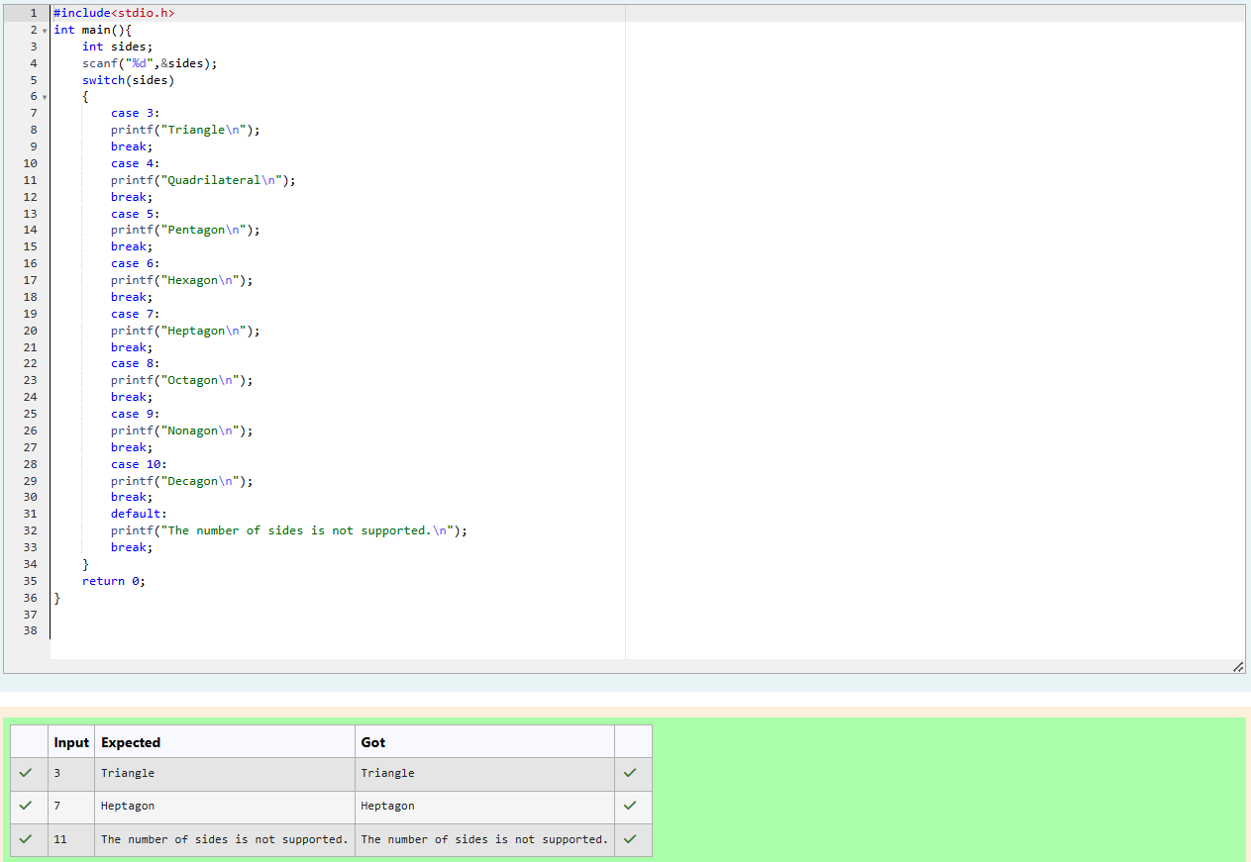
Problem Statement:
The Chinese zodiac assigns animals to years in a 12-year cycle. One 12-year cycle is
shown in the table below. The pattern repeats from there, with 2012 being another year of
the Dragon, and 1999 being another year of the Hare.
Year Animal
2000 Dragon
2001 Snake
2002 Horse
2003 Sheep
2004 Monkey
2005 Rooster
2006 Dog
2007 Pig
2008 Rat
2009 Ox
2010 Tiger
2011 Hare
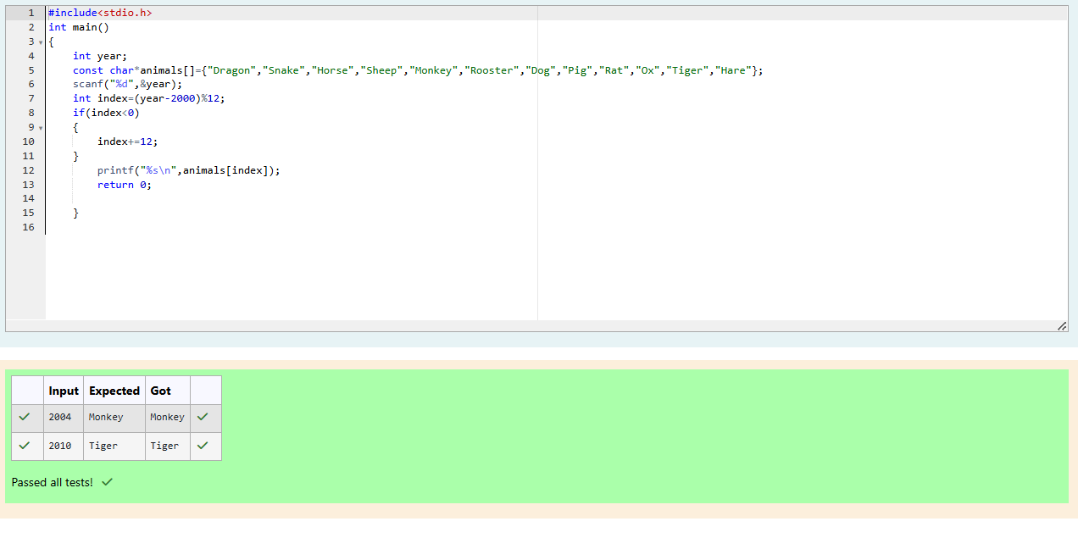
Problem Statement:
Positions on a chess board are identified by a letter and a number. The letter identifies the
column, while the number identifies the row, as shown below:
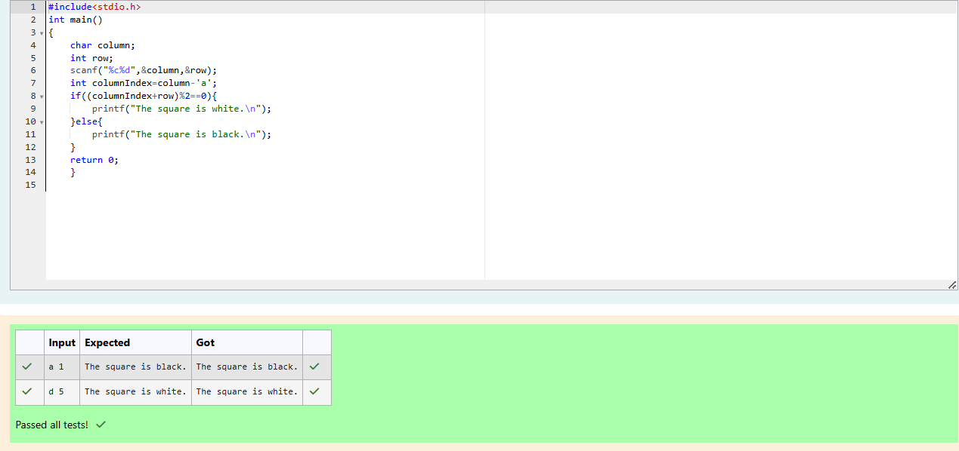
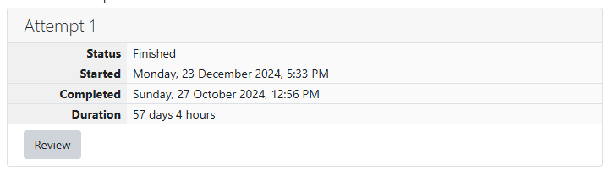
Problem Statement:
Some data sets specify dates using the year and day of year rather than the year, month,
and day of month. The day of year (DOY) is the sequential day number starting with day 1
on January 1st.
There are two calendars - one for normal years with 365 days, and one for leap years with
366 days. Leap years are divisible by 4. Centuries, like 1900, are not leap years unless
they are divisible by 400. So, 2000 was a leap year.
To find the day of year number for a standard date, scan down the Jan column to find the
day of month, then scan across to the appropriate month column and read the day of year
number. Reverse the process to find the standard date for a given day of year.
Write a program to print the Day of Year of a given date, month and year.
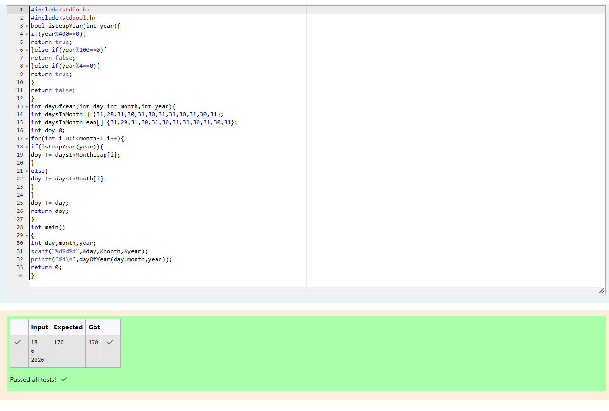
Problem Statement:
Suppandi is trying to take part in the local village math quiz. In the first round, he is asked
about shapes and areas. Suppandi, is confused, he was never any good at math. And also,
he is bad at remembering the names of shapes. Instead, you will be helping him calculate
the area of shapes.
• When he says rectangle, he is actually referring to a square.
• When he says square, he is actually referring to a triangle.
• When he says triangle, he is referring to a rectangle
• And when he is confused, he just says something random. At this point, all you can
do is say 0.
Help Suppandi by printing the correct answer in an integer.
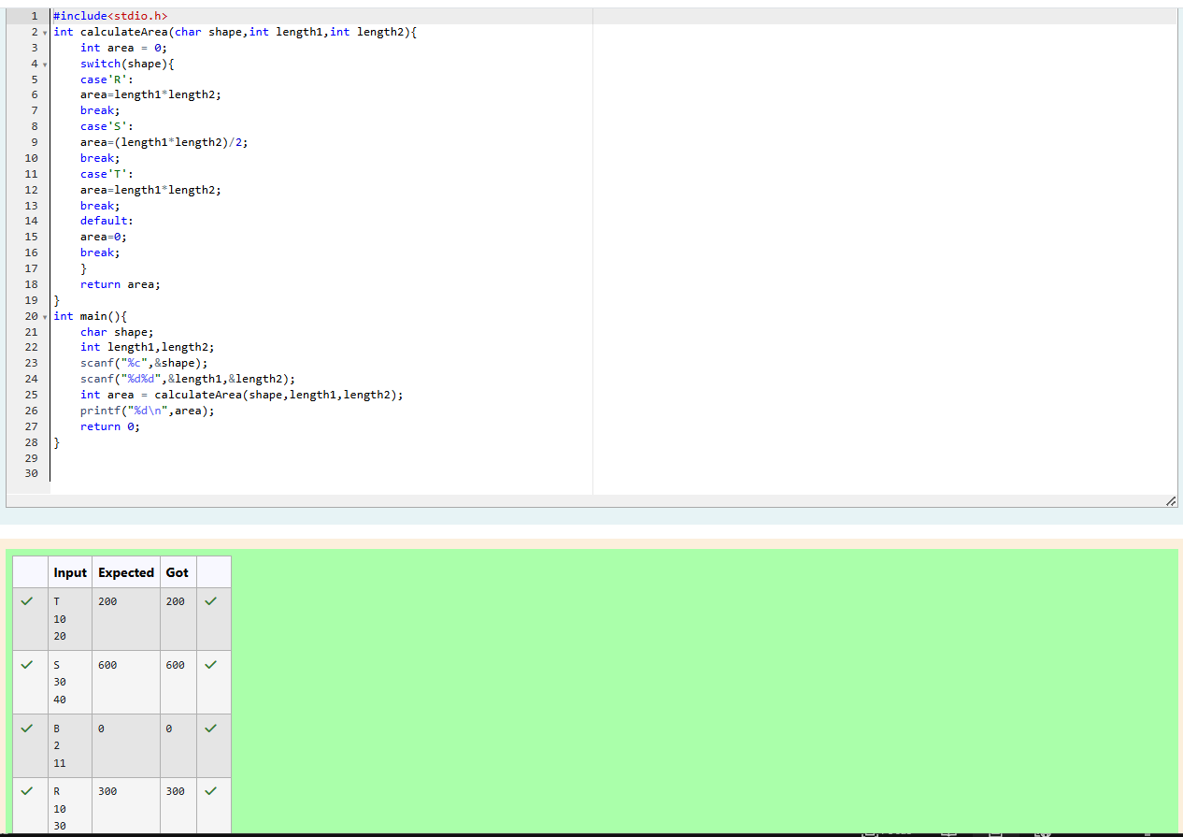
Problem Statement:
Superman is planning a journey to his home planet. It is very important for him to know
which day he arrives there. They don't follow the 7-day week like us. Instead, they follow
a 10-day week with the following days:
Day Number Name of Day
1 Sunday
2 Monday
3 Tuesday
4 Wednesday
5 Thursday
6 Friday
7 Saturday
8 Kryptonday
9 Coluday
10 Daxamday
